TANGA REMEMBERED – September 2012
I left Tanga in the late 1950’s when I was just ten years old. In September 2012, I decided to pay what I think might be my last visit to the place where I was born to refresh memories and reminisce old days after being away more than five decades. I had mixed feelings. The sad thing being all the old charm of a bustling little town had disappeared. It is more or less a ghost town. However, the satisfying feeling was the old buildings in downtown areas are mostly still intact and recognizable albeit run down, some dilapidated and rapidly crumbling to extinction. If I was a multi-millionaire, I would not hesitate a minute to reinstate all the old buildings to their full glory of German and British heritage. Alas, I am not one and it saddens me deeply to think our past history is rudely ignored and left to wither by the current rulers without any sense of responsibility.
Of the old families I knew were: my Uncle Sultan Baig Mirza (Railways), Police Chief Hameed Khan and his sons, Dr Krishna, his wife Dr Satiya and her brother Dr Sood who had built a new clinic in the mid-1950’s in Ngamiani, Dr Dias, Master Ayaz and his family, Hussain Bux, Imdad Ali, Tuwasal Hussain, Barakat Ali, (Mistry) Hayat, the Mughal family, Hanid family who built bodies for trucks, Ms Kubra who was the only Asian lady I knew who drove a car in Tanga in the mid-1950’s, the Shafi family of Kanga.
The E A Safari rally used to pass through Tanga. Princess Margaret visited us in 1956. Tanga airport used to be the venue for car racing events with rare appearances of a Jaguar D-type and a Porsche Carrera with good participations by both Muhindi and Mazungu competitors.
In 1956, the Pakistan cricket team visited us and played a match at the Bohora club. Notable players from Pakistan were Hanif Mohd, Imtiaz Ahmed, Waqar Hasan, Maqsood Ahmed, Wallis Mathia. I remember Chambers was a good player from Tanga.
Lata Mangeshkar and Talat Mahmood the famous Indian playback singers visited us circa 1957 and performed at the Majestic Cinema.
The old ‘buyu’ tree of the WWII fame still stands in the vacant ground opposite the Gurdwara. Legend has it that a German woman put a strong resistance against the British (or was it the other way round?) killing a number of their soldiers before while hidden on top eventually giving away her own life.
I was happy to see the landmark Sachak house still there opposite the Post Office. I was distraught to see the sad state of the old Bombo Hospital Cliff Ward. What a splendid building it was in the old days. I wish it could be sympathetically reinstated simply as an architectural and a historical building of the German occupancy of Tanga.

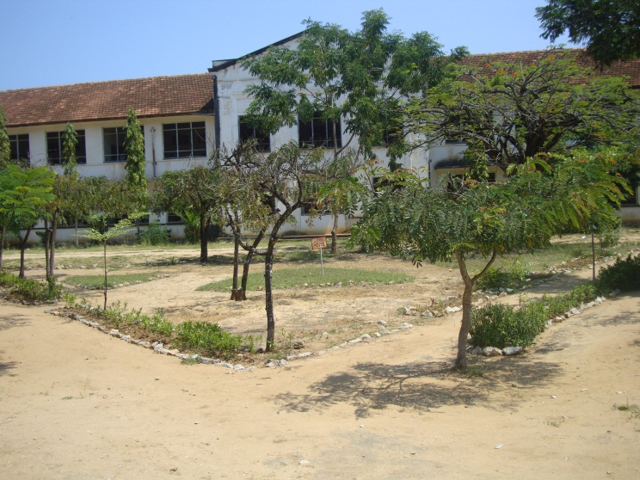  Karimjee Primary School – 01: | 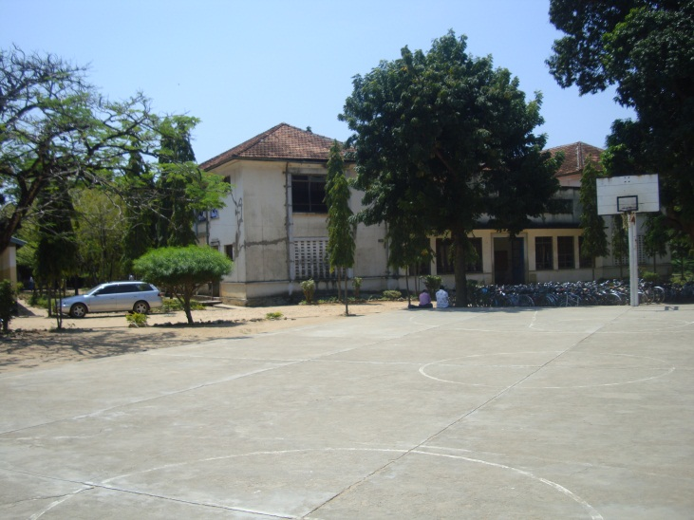  Karimjee Primary School – 02:
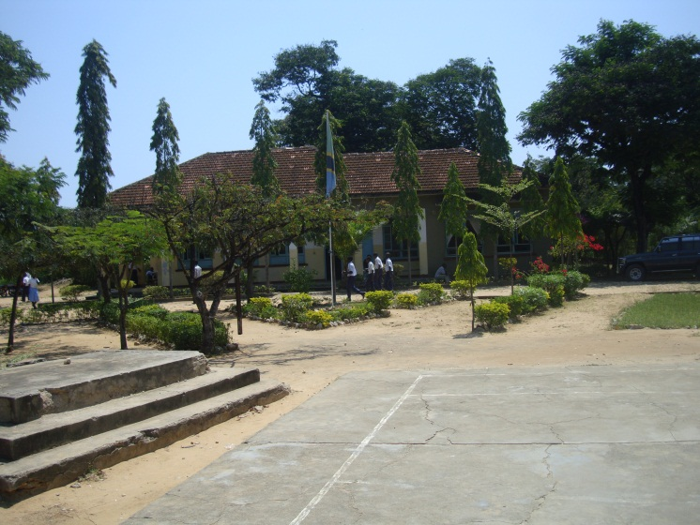Karimjee Primary School – 03: The Headmaster’s Office where Mr Perry was in charge until 1955 (I think). Mr Ranger was his assistant until his tragic death at the Pangani River incident. | 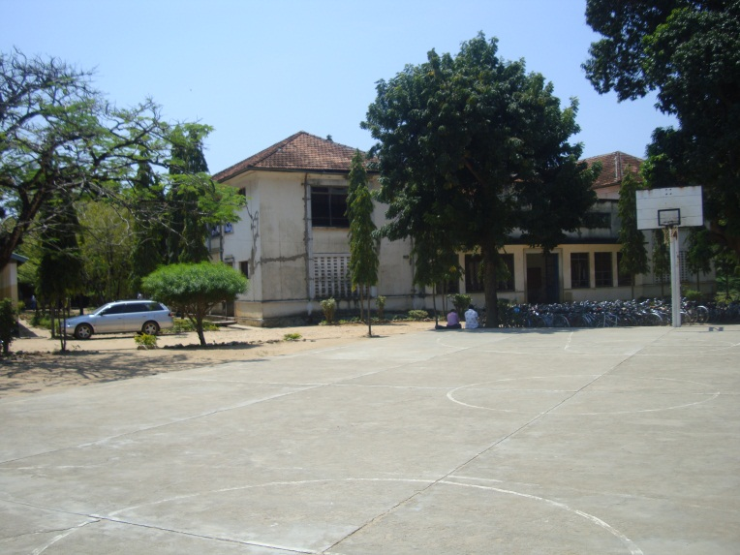  Karimjee Primary School – 04: The classroom block adjacent the main entrance gate.
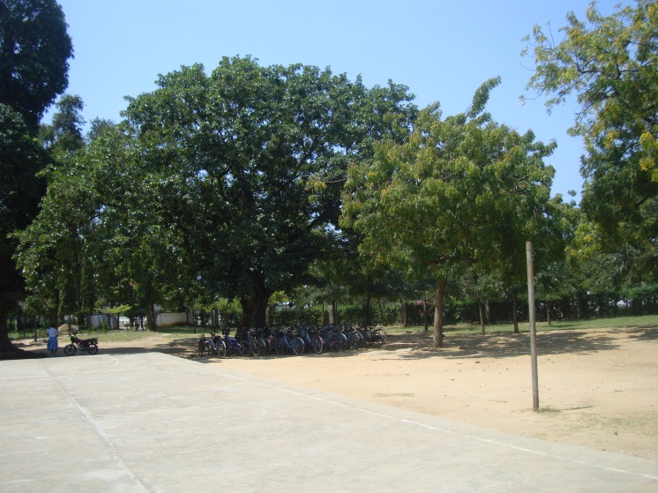  Karimjee Primary School – 05: The big mango tree at the centre of the main grounds where morning assemblies were held in the open. | 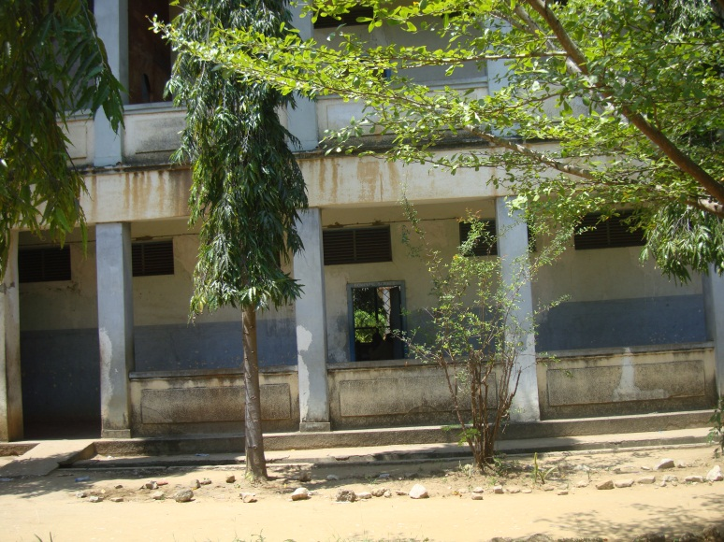  Karimjee Primary School – 06: Classroom block with Standard I at ground floor where I first enrolled in January 1954. We had a Sikh madam (divorced) who used to be smartly dressed up in colourful saris. I can’t remember her name though.
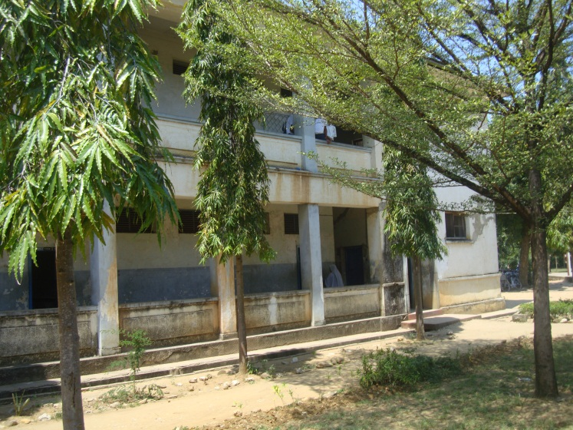  Karimjee Primary School – 07: The Junior Block again. Notable teachers were Master Karam Singh, Karnail Singh. Mr M A Ayaz had a class at the upper floor and was also in charge of stationary at the end of the corridor. | 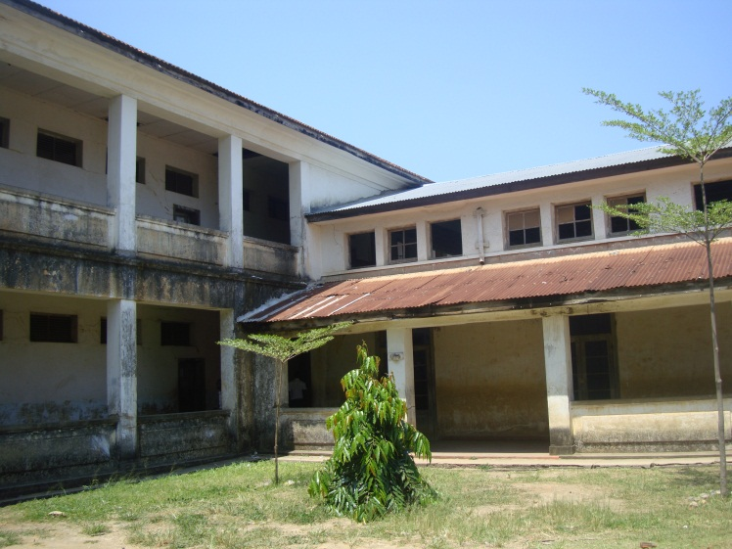  Karimjee Primary School – 08: Another view of the dilapidated classrooms. A sad reflections of its glorious past.
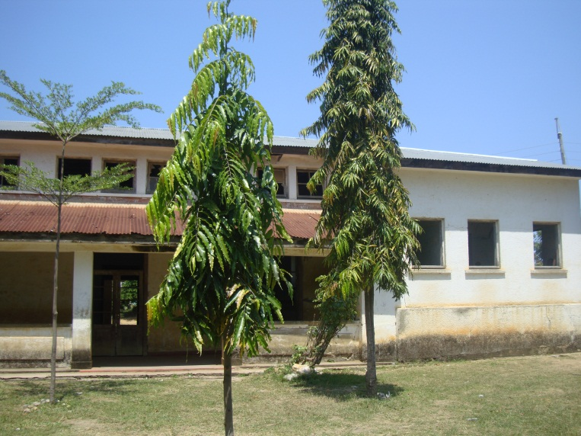  Karimjee Primary School – 09: The wing where indoor dramas and plays used to be held | 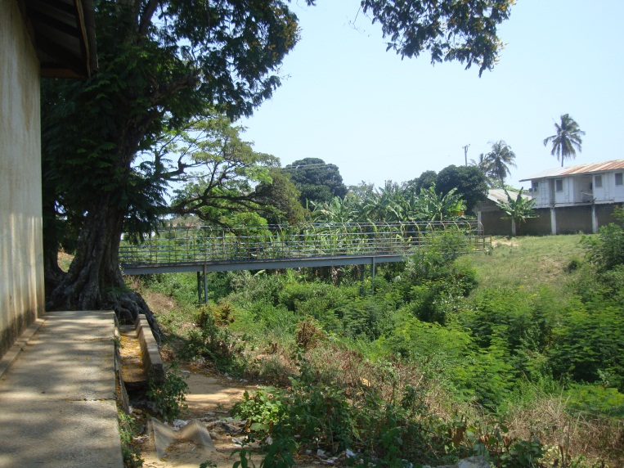  Karimjee Primary School – 10: The footbridge over the railway line that used to take us towards Dr. Dias’s clinic and the famous ‘buyu’ tree which had a legendary story during WWII
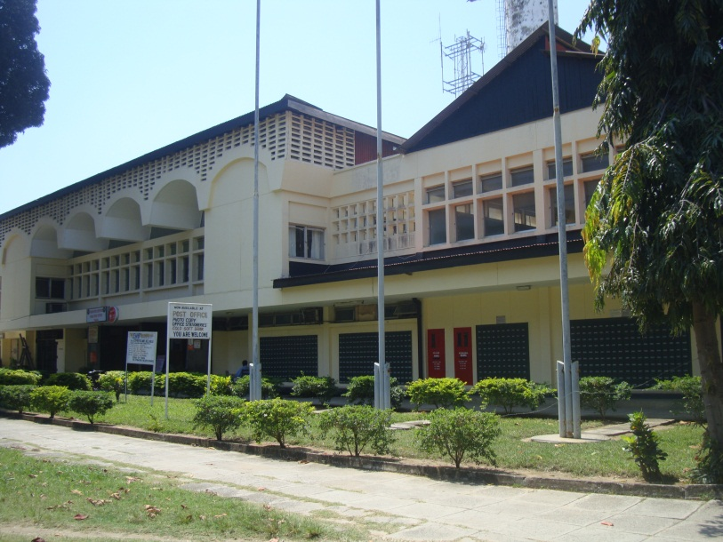  Independence Avenue Tanga – 01: The still impressive Post Office | 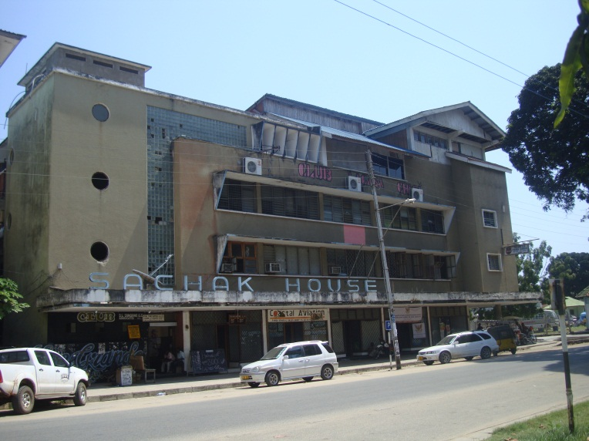  Independence Avenue Tanga – 02: The landmark Sachak House
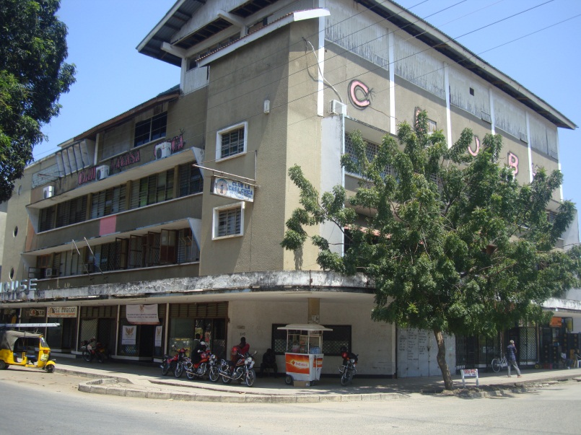  Independence Avenue Tanga – 03: Side View of Sachak House | 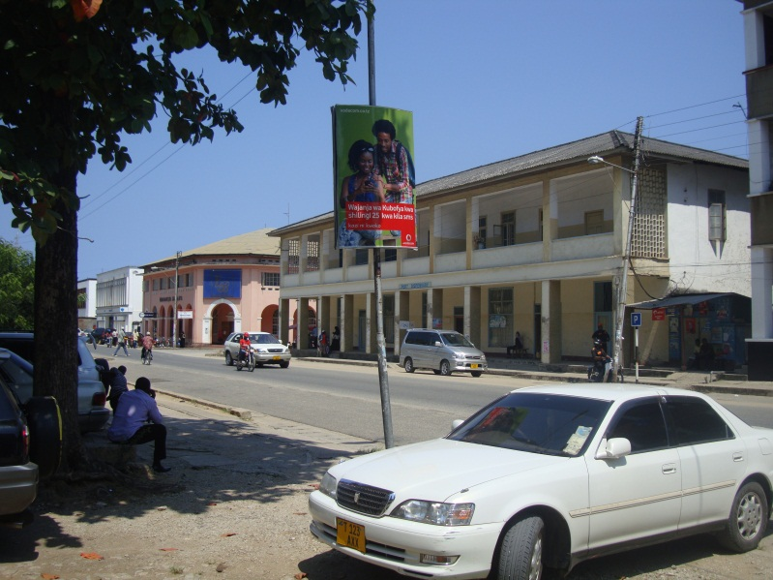  Independence Avenue Tanga - 04: Building to the side of Sachak House
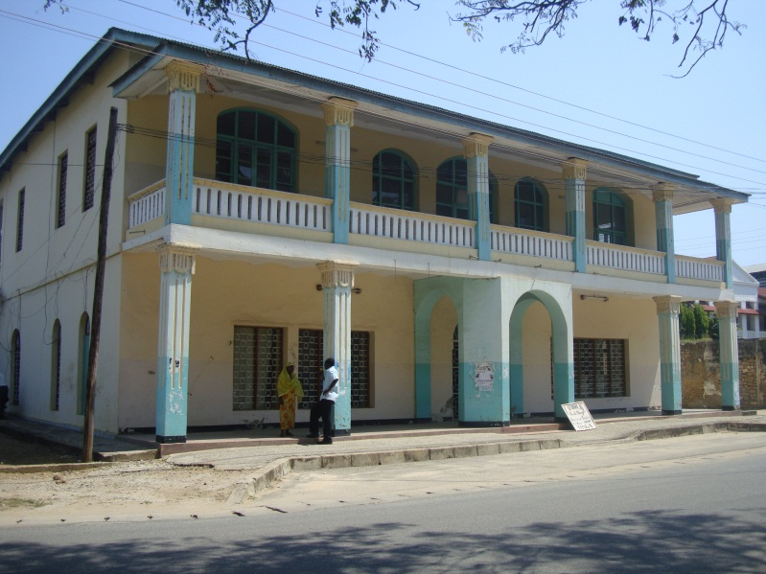  Independence Avenue Tanga – 05: A beautiful colonial building still in good shape | 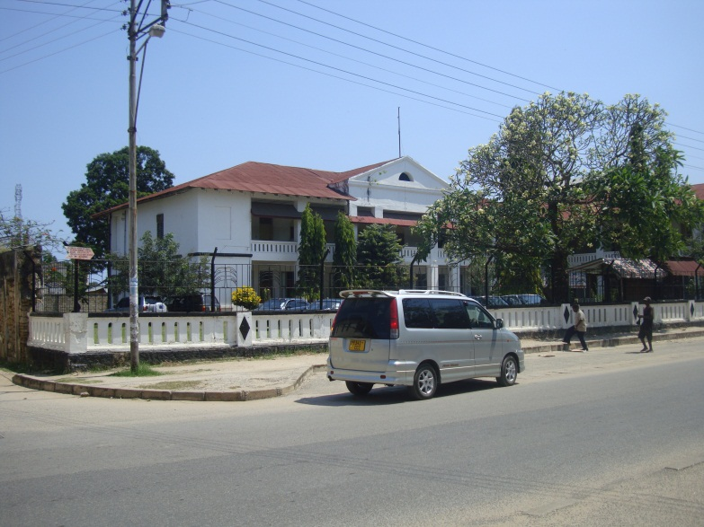  Independence Avenue Tanga – 06: Independence Avenue I believe this was a Hotel in the colonial days. Now an office. See 05 below
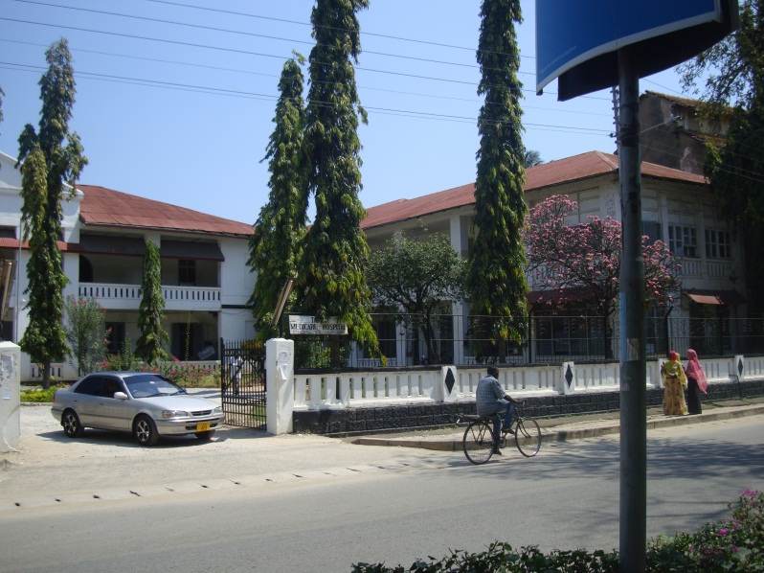  Independence Avenue Tanga – 07: | 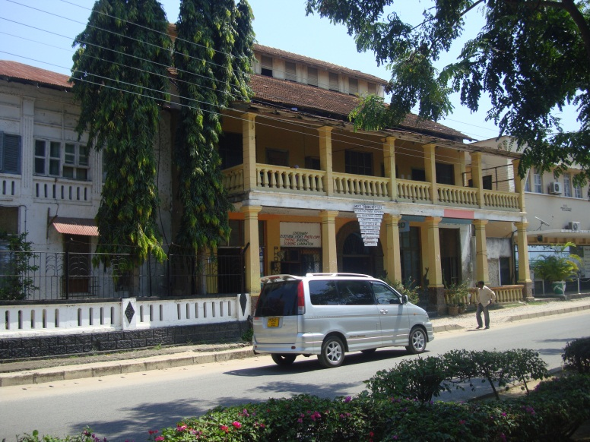  Independence Avenue Tanga – 08: See 09 below also
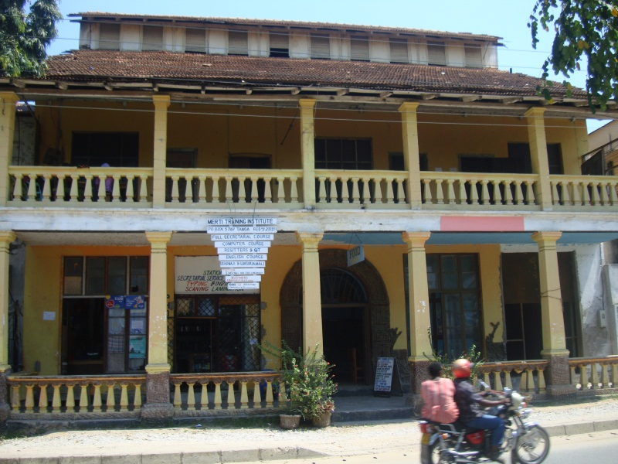  Independence Avenue Tanga – 09: | 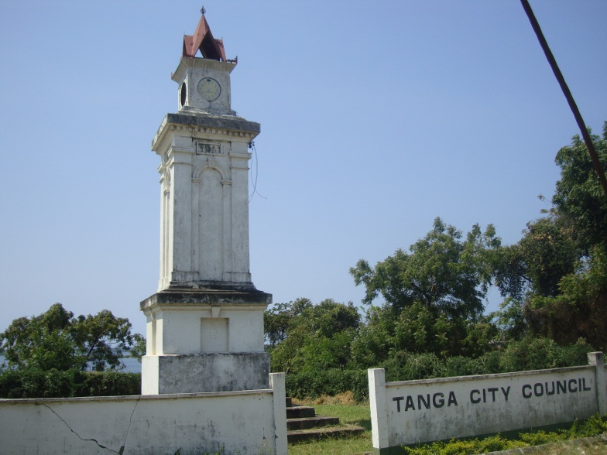  Independence Avenue Tanga – 10: A few things never change
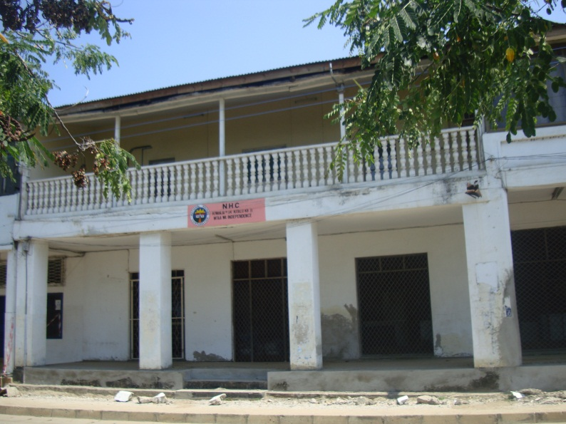  Independence Avenue Tanga - 11: | 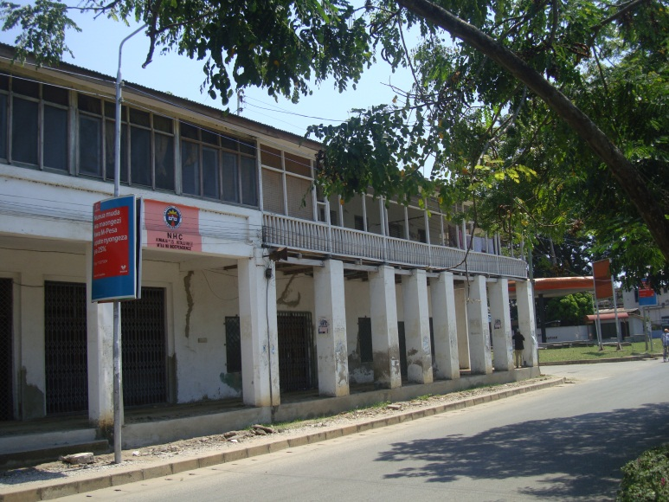  Independence Avenue Tanga – 12:
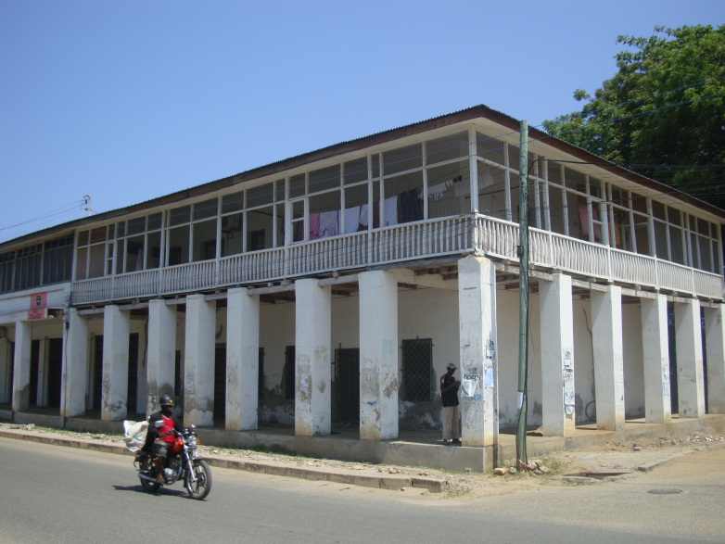  Independence Avenue Tanga – 13: | 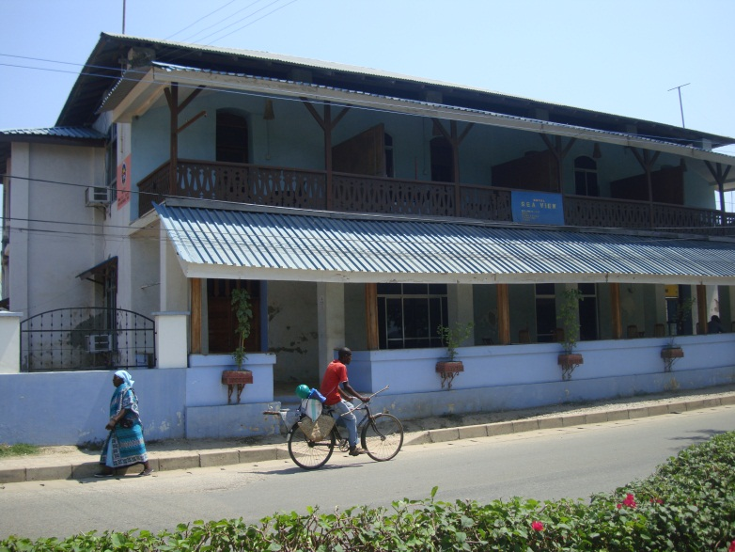  Independence Avenue Tanga – 14: Sea View Hotel. I wonder if it is the old hotel of colonial days?
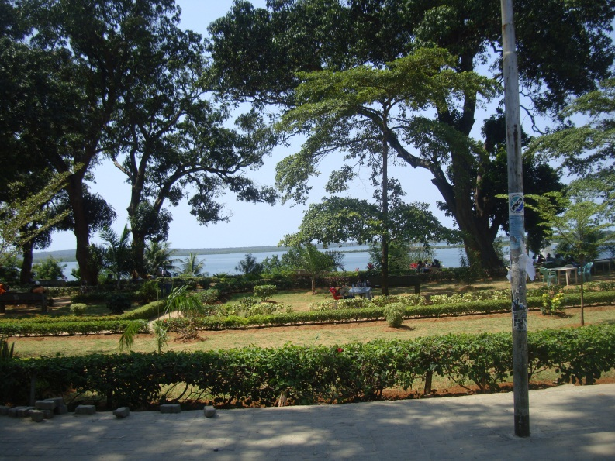  Independence Avenue Tanga – 15: Beautiful park opposite Sea View Hotel | 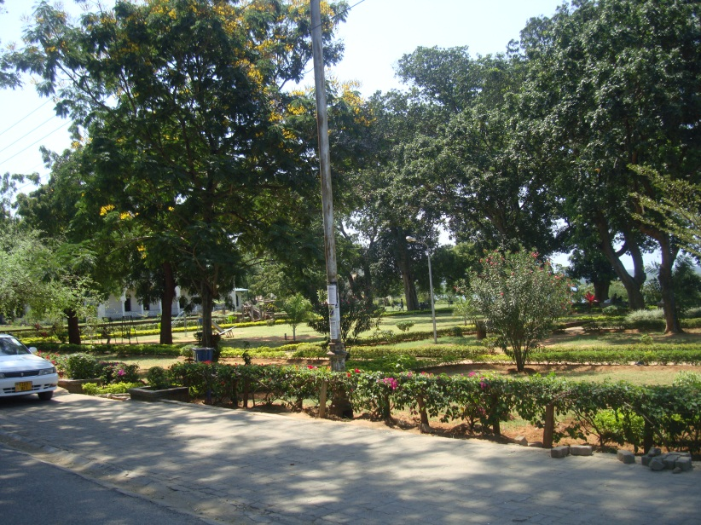  Independence Avenue Tanga -16: Another view of the park
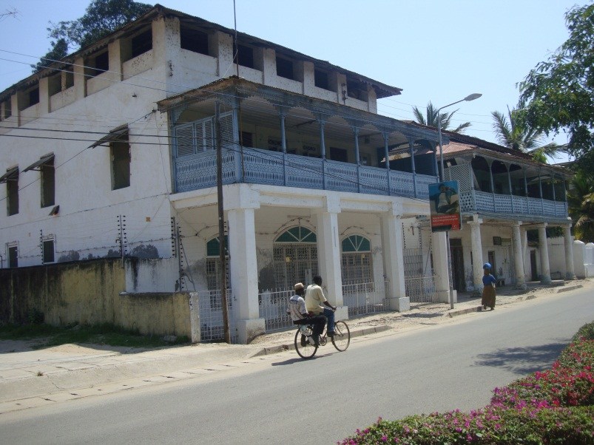  Independence Avenue Tanga – 17: | 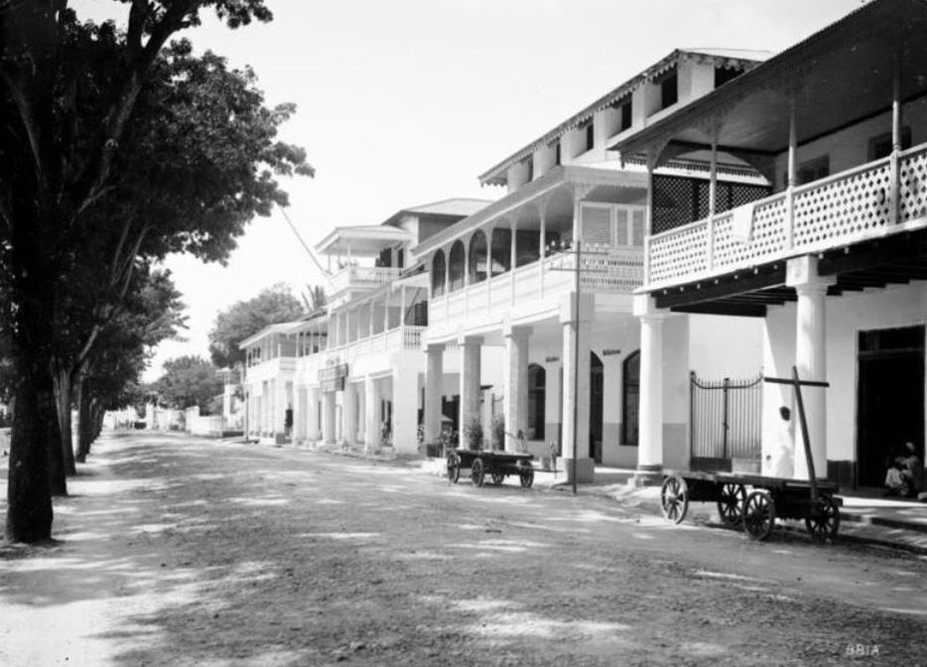  Independence Avenue Tanga – 18: The same buildings of Picture 17 as seen in the early 1900’s during German occupation. (View taken from opposite end)
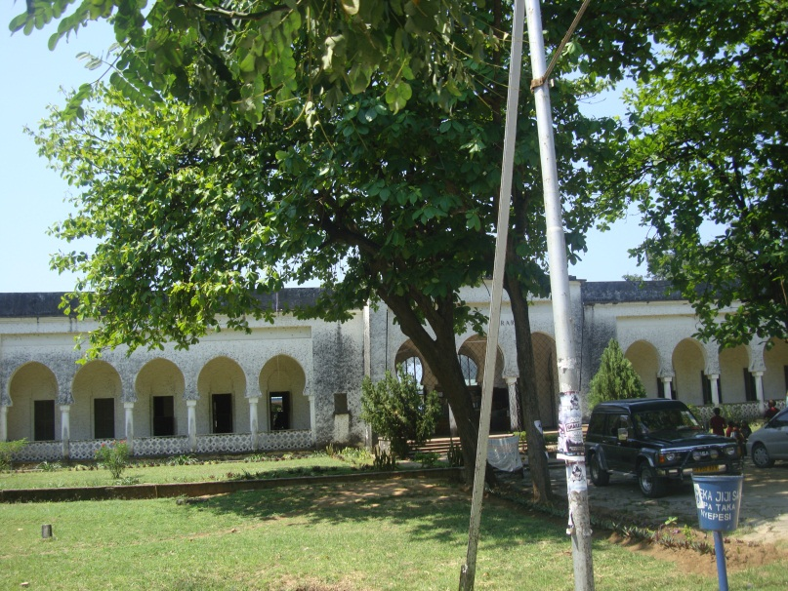  Independence Avenue Tanga -19: | 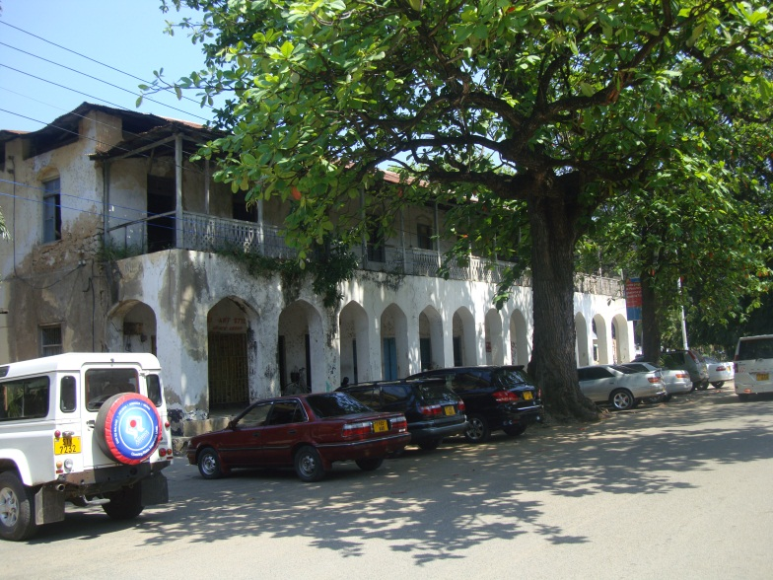  Independence Avenue Tanga – 20:
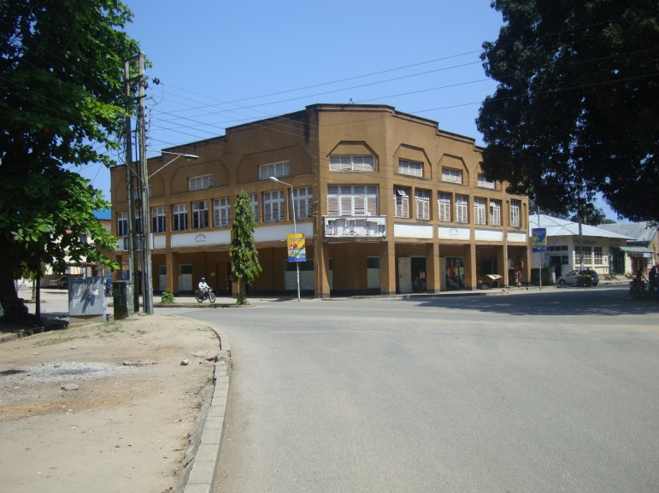Market Street Tanga – 21: See Picture 22 (right) | 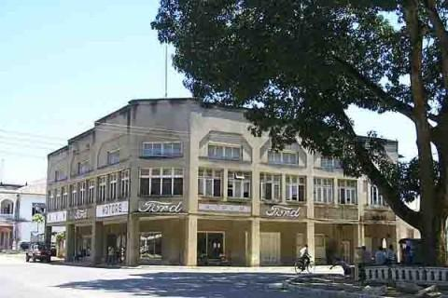  Market Street Tanga – 22: Same Building in the 1950’s occupied by Ford Motor Company
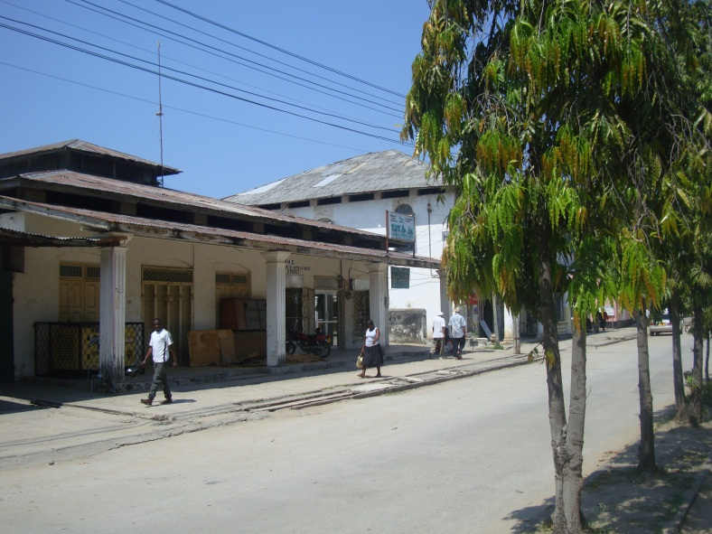  Market Street Tanga - 23: Opposite former Ford Motor Building. These shops used to be Mazungu grocery shops. | 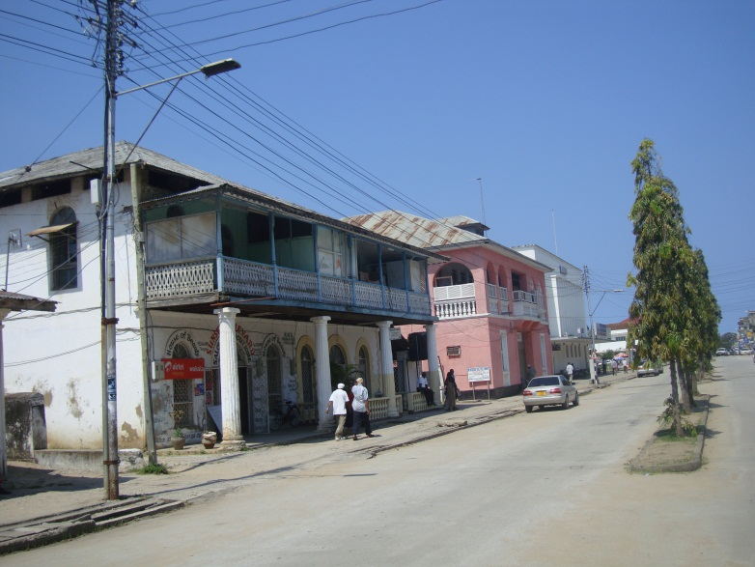  Market Street Tanga – 24: Old Mazungu grocery shops used be here in this area
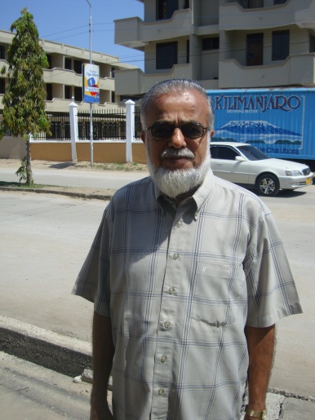  Market Street Tanga – 25: Mr. Rasheed a shop owner still living in and loving Tanga | 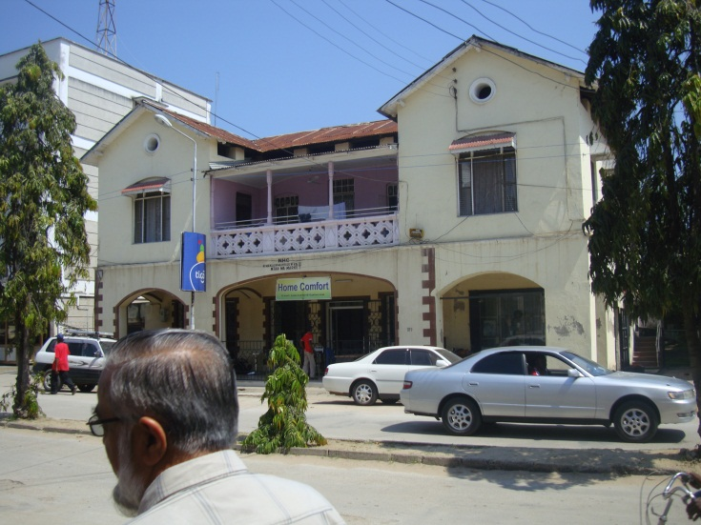  Market Street Tanga -26:
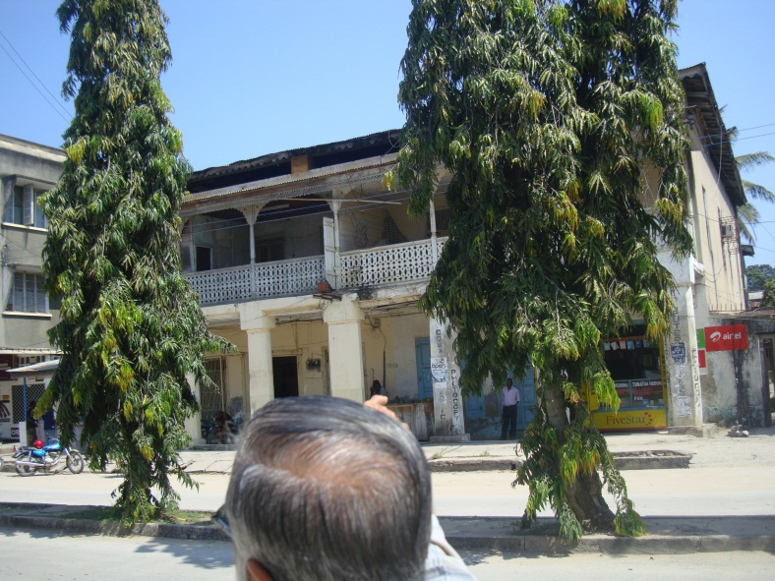  Market Street Tanga – 27: | 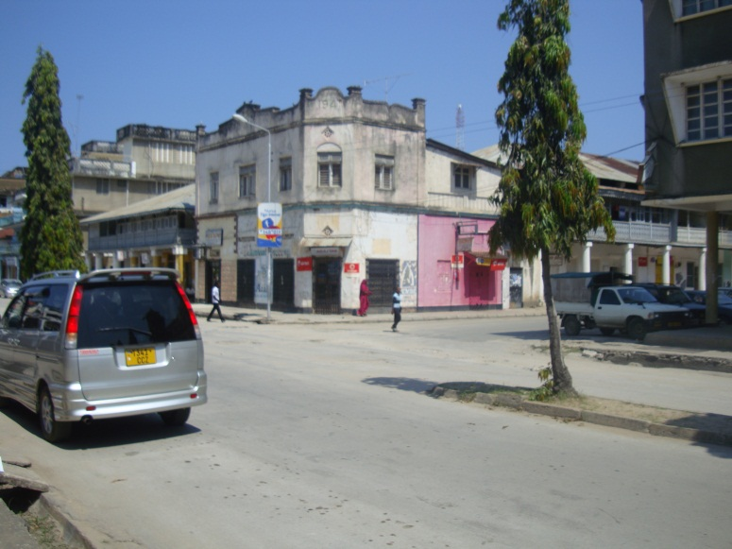  Market Street Tanga – 28: Popatlal & Sons shop at the corner was here in the 1950’s
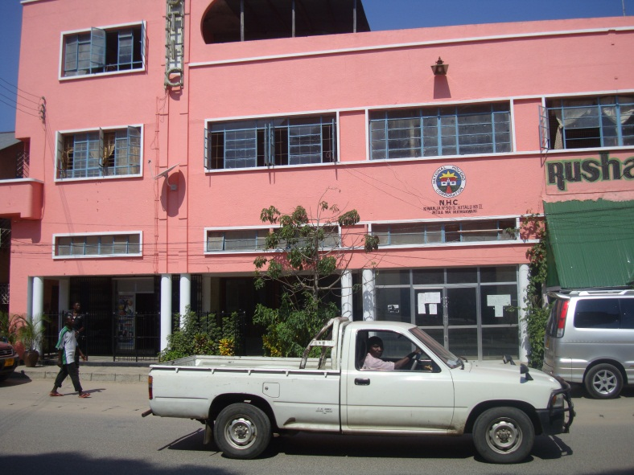  Downtown Tanga – 29: Where Majestic Cinema used to be in the 1950’s | 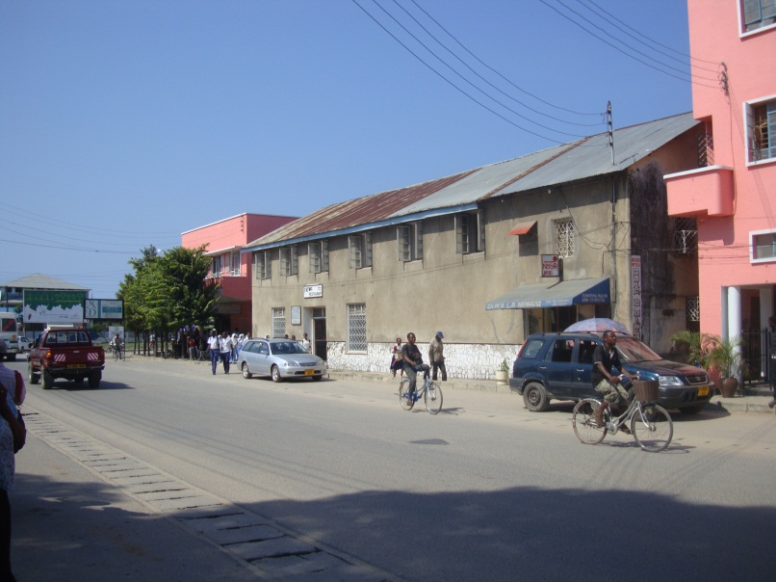  Downtown Tanga – 30: Patwa’s Restaurant to the left of old Majestic Cinema Building. The other pink shop at the corner used to be Bata Shoe shop
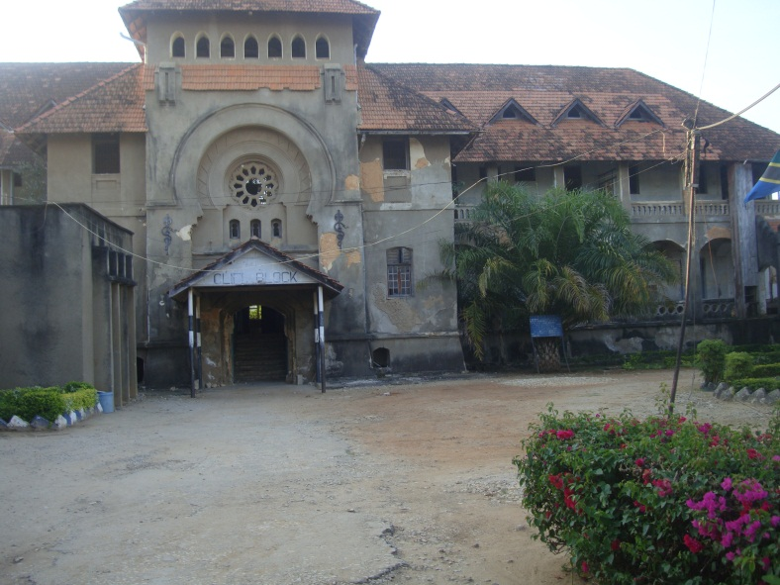  Bombo Hospital Cliff Block – 01: The very sad and dilapidated state of once a magnificent German built hospital on the sea front constructed circa 1894 | 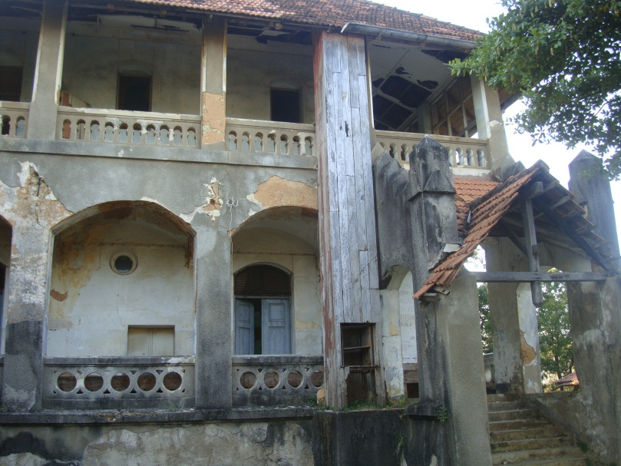 Bombo Hospital Cliff Block – 02: Just heart breaking
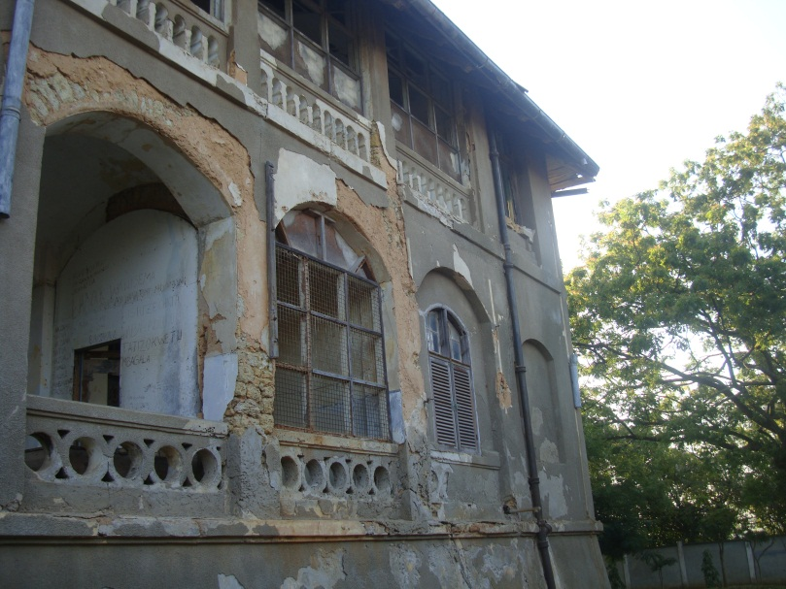  Bombo Hospital Cliff Ward – 03: | 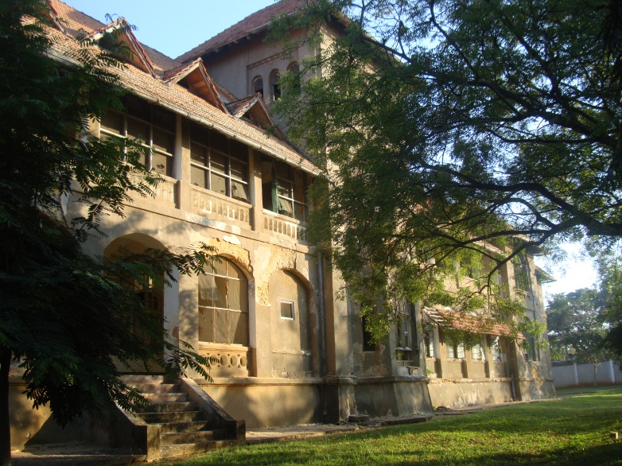  Bombo Hospital Cliff Block – 04: Rear View facing the sea
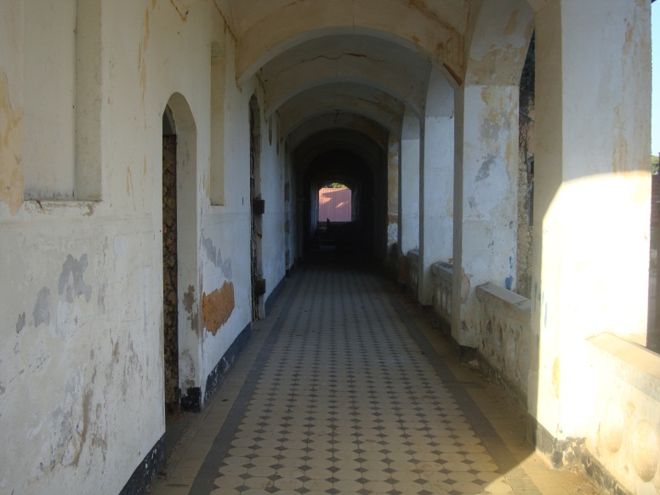  Bombo Hospital Cliff Ward - :05 Corridor at first floor leading to the wards | 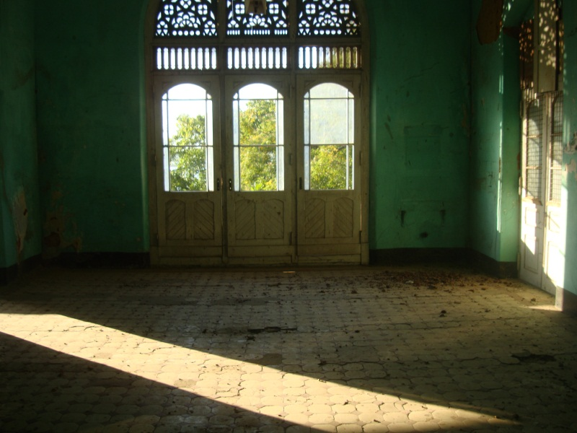  Bombo Hospital Cliff Ward – 06: A typical in-patients ward which once accommodated several beds
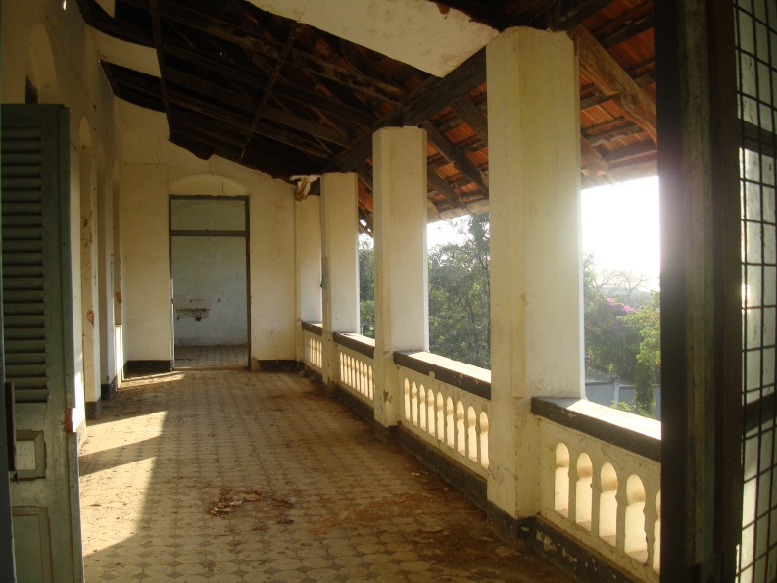
Bombo Hospital Cliff Ward – 07: What was a magnificent balcony once upon a time

